NIRVANA FARMS
Information Memorandum – content draft
Forestry and carbon estate – Taranaki / Whanganui hill country · receivership sale by expressions of interest
Prepared by | Searle Forestry (Forestry Sales Limited, Licensed Agent REA Act 2008)
Draft | v1 – 6 October 2026 – content for the designer's IM layout (Nirvana Farms Draft.pdf)
Status | Working draft for the Receivers' review. Items shown in red [TBC] are to be confirmed or supplied before release.
Vendors | Nirvana Farm Limited (In Receivership); and Andrew Grenfell and Kare Johnstone (McGrathNicol) as receivers of 27 Makowhai Trust titles

How to use this draft
This document carries the words, figures, tables and charts that fill the designer's IM template. It follows the IM page order: executive summary, estate summary, then one summary per block. Blocks are ordered by location and size with the Pinus radiata blocks first.
- Red [TBC] text marks facts not yet on file or not yet confirmed by the Receivers; a consolidated list is in Appendix B.
- Grey 'internal note' boxes are for the Searle team and the designer and are not IM copy.
- Charts are supplied as PNG files in the IM/charts folder beside this document and can be rebuilt from the same data.
- All areas are LINZ record-of-title areas; land-cover areas are GIS-derived from the July 2026 appraisal mapping and are approximate. No valuation figures are included – appraisal values stay out of the IM.
Internal note – not for the IM: Branding: the designer's draft uses the Searle Agribusiness template and @searleagri.co.nz contacts, but the agency agreements are with Forestry Sales Limited trading as Searle Forestry. This draft uses Searle Forestry details – please confirm which brand the IM should carry before layout.

1 Executive summary
Nirvana Farms is a 13,800 hectare forestry and carbon estate across the hill country between Waverley, the Waitōtara Valley and Whangamomona in eastern Taranaki, with one outlying block near Ōpōtiki. It is offered for sale by the receivers of Nirvana Farm Limited and of the Makowhai Trust titles, as a whole or in parts, by expressions of interest.
The estate comprises 16 blocks in 56 freehold and Crown-leasehold titles, together with two registered forestry rights held by Nirvana Farm Limited, including a right over a further 362 ha at Soldiers Road. About 2,597 ha of Pinus radiata was established across eight blocks between 2022 and 2024 and is registered in the New Zealand Emissions Trading Scheme (ETS), most of it under averaging accounting. A further 9,190 ha is native bush and regenerating mānuka/kānuka, and roughly 2,141 ha is open hill-country grassland, of which about 3,190 ha is indicatively post-1989 land and potentially eligible for ETS registration.
An independent ground survey by PF Olsen in April 2026 found 1,673 ha of the young crop adequately stocked (above 850 stems/ha) and programmed 406 ha of replanting and 417 ha of blanking for the 2026 season, restoring about 2,497 ha of adequately stocked crop. That programme has been carried out ahead of schedule and is due to be complete by the end of September 2026 [TBC – confirm completion]; completion certification, survival plots and an independent third-party review of the planted areas will be provided in the data room. A further 219 ha of plantable open ground has been identified on four blocks.
The carbon position is substantial. MPI land status reports record about 2,740 ha of registered carbon accounting areas across the estate with a combined unit balance of roughly 149,500 NZUs, including two permanent-forest accounting areas of older radiata at Longreach and Back Farm. The NFL carbon account is controlled by NZGT as trustee, which will control the transfer of units at settlement; NZUs are to be transferred with the property [TBC – NZU balance and treatment of the forward sale to the financier].
About 2,260 ha of Front Farm, the Eastern Block and one Puau Road Crown lease is subject to a grazing lease to Pukekahu Farms Limited expiring 31 December 2029; rent for the full term has been prepaid and the lease may be terminated by the landlord on five months' notice. Farming continues and stock will be present on parts of the estate. The former owner's honey business, the Magons property and the private residence are not included.
The estate is being offered by expression of interest with international coverage so that the process can be tailored to purchasers' needs – whether for the whole estate, the planted forest blocks, or the native and mānuka blocks separately. The sale is a receivership sale on an "as is, where is" basis.

Key facts
Vendor | Nirvana Farm Limited (In Receivership) and the receivers of the Makowhai Trust titles – Andrew Grenfell and Kare Johnstone, McGrathNicol
Estate type | Forestry and carbon estate – young Pinus radiata, permanent and regenerating forest, native bush and mānuka/kānuka
Tenure | Freehold (54 titles) and two Crown renewable leases (s82 Land Act 1948, Puau Road); two registered forestry rights held by Nirvana Farm Limited
Total titled area | 13,832 ha in 16 blocks (6,045 ha NFL, 7,787 ha Makowhai Trust) plus a forestry right over 362 ha at Soldiers Road
Planted area | 2,597 ha Pinus radiata (2022–2024 plantings) including 176 ha under the Soldiers Road forestry right; 2,497 ha adequately stocked after the 2026 programme
Native and scrub | 4,673 ha native bush and 4,518 ha mānuka/kānuka/scrub
Open grassland | about 2,141 ha, of which about 3,190 ha is indicatively ETS-eligible (post-1989)
ETS | Registered by Nirvana Farm Limited (NZ-10251) and Makowhai Station (NZ-1181); about 2,740 ha of carbon accounting areas, mostly averaging; two permanent-forest CAAs to 2060
NZU balance | CAA unit balance about 149,500 NZUs per MPI land status reports [TBC – holding account balance from NZGT / JTL]
Leased area | About 2,260 ha to Pukekahu Farms Limited, five-year term to 31 December 2029, rent prepaid
Territorial authorities | South Taranaki, Stratford, Whanganui and Ōpōtiki District Councils [TBC per title]
Regional councils | Taranaki, Horizons (Manawatū-Whanganui) and Bay of Plenty Regional Councils
Zoning | Rural [TBC per district plan]
Legal access | Road frontage to most blocks; no legal access issues known. Parts of Front Farm, the Eastern Block and Puau Road are worked through neighbouring properties [TBC – access details from Stand]
Rating valuation / rates | [TBC – rating valuations and annual rates for all 56 titles]
Sale method | Expressions of interest closing [TBC date and time], plus GST (if any)

Investment highlights
- Scale: one of the largest forestry and carbon land holdings offered in the lower North Island, with 56 titles in four locations that can be taken as a whole or in parts.
- 2,597 ha of young Pinus radiata registered in the ETS under averaging, with a 2026 remediation programme completed by the vendor [TBC].
- Permanent-forest carbon accounting areas of older radiata at Longreach and Back Farm with a combined unit balance of about 102,000 NZUs to 2060.
- About 3,190 ha of indicatively ETS-eligible open and scrub land and 219 ha of identified plantable ground for further afforestation.
- Large mānuka/kānuka and native forest areas suited to honey, regeneration and biodiversity uses.
- Receivership sale with a clear EOI process and a full data room: titles, forestry rights, lease, ETS land status reports, CAA geospatial data and the PF Olsen survey.
Internal note – not for the IM: The exec summary tiles on IM page 4 map to the Key facts table above. The planted-area tile should read '2,597 ha' (including the Soldiers Road forestry right) or '2,421 ha' (land in the sale only) – pick one and use it consistently.

2 Estate summary

2.1 The estate at a glance
The estate falls into four locations. Three are in the Taranaki–Whanganui hill country within about an hour and a half of Whanganui or Stratford; the fourth, Pakihi, is an outlying mānuka block inland from Ōpōtiki.
Block | Location | Vendor | Titles | Area (ha) | Radiata planted (ha) | Main land cover
Back Farm | A | Makowhai Trust | 8 | 2,104.4 | 785 | Native / scrub with radiata
Longreach | A | NFL | 4 | 1,723.1 | 777 | Pinus radiata / native / scrub
Eastern Block | A | Makowhai Trust | 3 | 1,071.5 | 138 | Native / scrub with radiata
Front Farm | A | Makowhai Trust | 5 | 502.1 | 231 | Pinus radiata / native / scrub
Puau Road | B | NFL | 4 | 1,871.7 | 52 | Native / scrub with radiata
Whangamomona | C | NFL | 1 | 738.9 | 355 | Pinus radiata / native / scrub
Soldiers Road (forestry right) | C | Forestry right (NFL) | 1 | 362.2 | 176 | Pinus radiata / native / scrub
Staghaven | C | NFL | 3 | 295.6 | 83 | Pinus radiata / native / scrub
Ernies | A | Makowhai Trust | 6 | 1,626.4 | – | Native bush / mānuka-kānuka
Karapara | A | Makowhai Trust | 3 | 1,317.7 | – | Native bush / mānuka-kānuka
Home Block | A | Makowhai Trust | 2 | 1,165.2 | – | Native bush / mānuka-kānuka
Patricks House | A | NFL | 3 | 27.7 | – | Dwelling block
Workers House | A | NFL | 2 | 1.7 | – | Dwelling block
Moonys | B | NFL | 4 | 643.6 | – | Native bush / mānuka-kānuka
Ridge Road | B | NFL | 3 | 282.6 | – | Native bush / mānuka-kānuka
Tims | C | NFL | 1 | 14.3 | – | Dwelling block
Pakihi | D | NFL | 4 | 445.6 | – | Native bush / mānuka-kānuka
Total – land in the sale |  |  | 56 | 13,832.0 | 2,421
Plus Soldiers Road forestry right | C | FR | – | (362.2) | 176

Location key: A – Waitōtara Valley / Ngamatapouri; B – Waverley / Nukumaru coast; C – Eastern Taranaki (Whangamomona and Mangaehu Road); D – Toatoa, Ōpōtiki District.
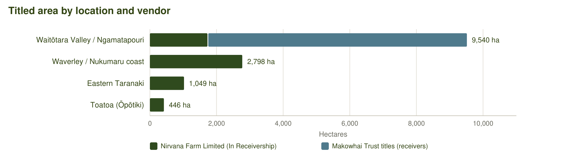
Figure 1 – Titled area by location and vendor.

2.2 Land cover
Land cover was mapped for the July 2026 appraisal from 10 m satellite imagery (summer 2023/24) with manual correction from recent aerial photography, with planted areas from PF Olsen's survey. Across the 13,832 ha of titled land in the sale, about 18% is planted pine or other exotic forest, 66% is native bush and mānuka/kānuka, and 15% is open grassland.
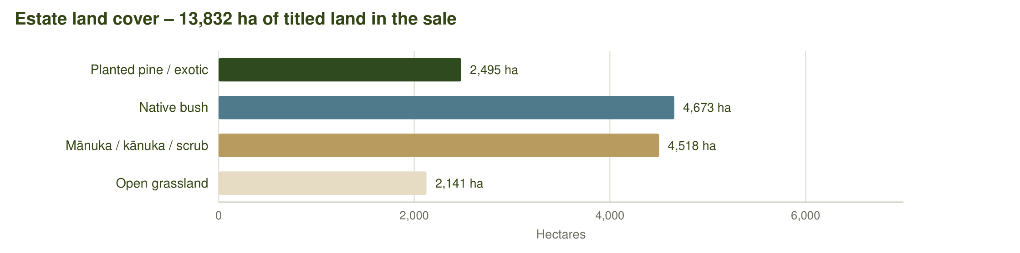
Figure 2 – Estate land cover (July 2026 mapping, titled land in the sale).
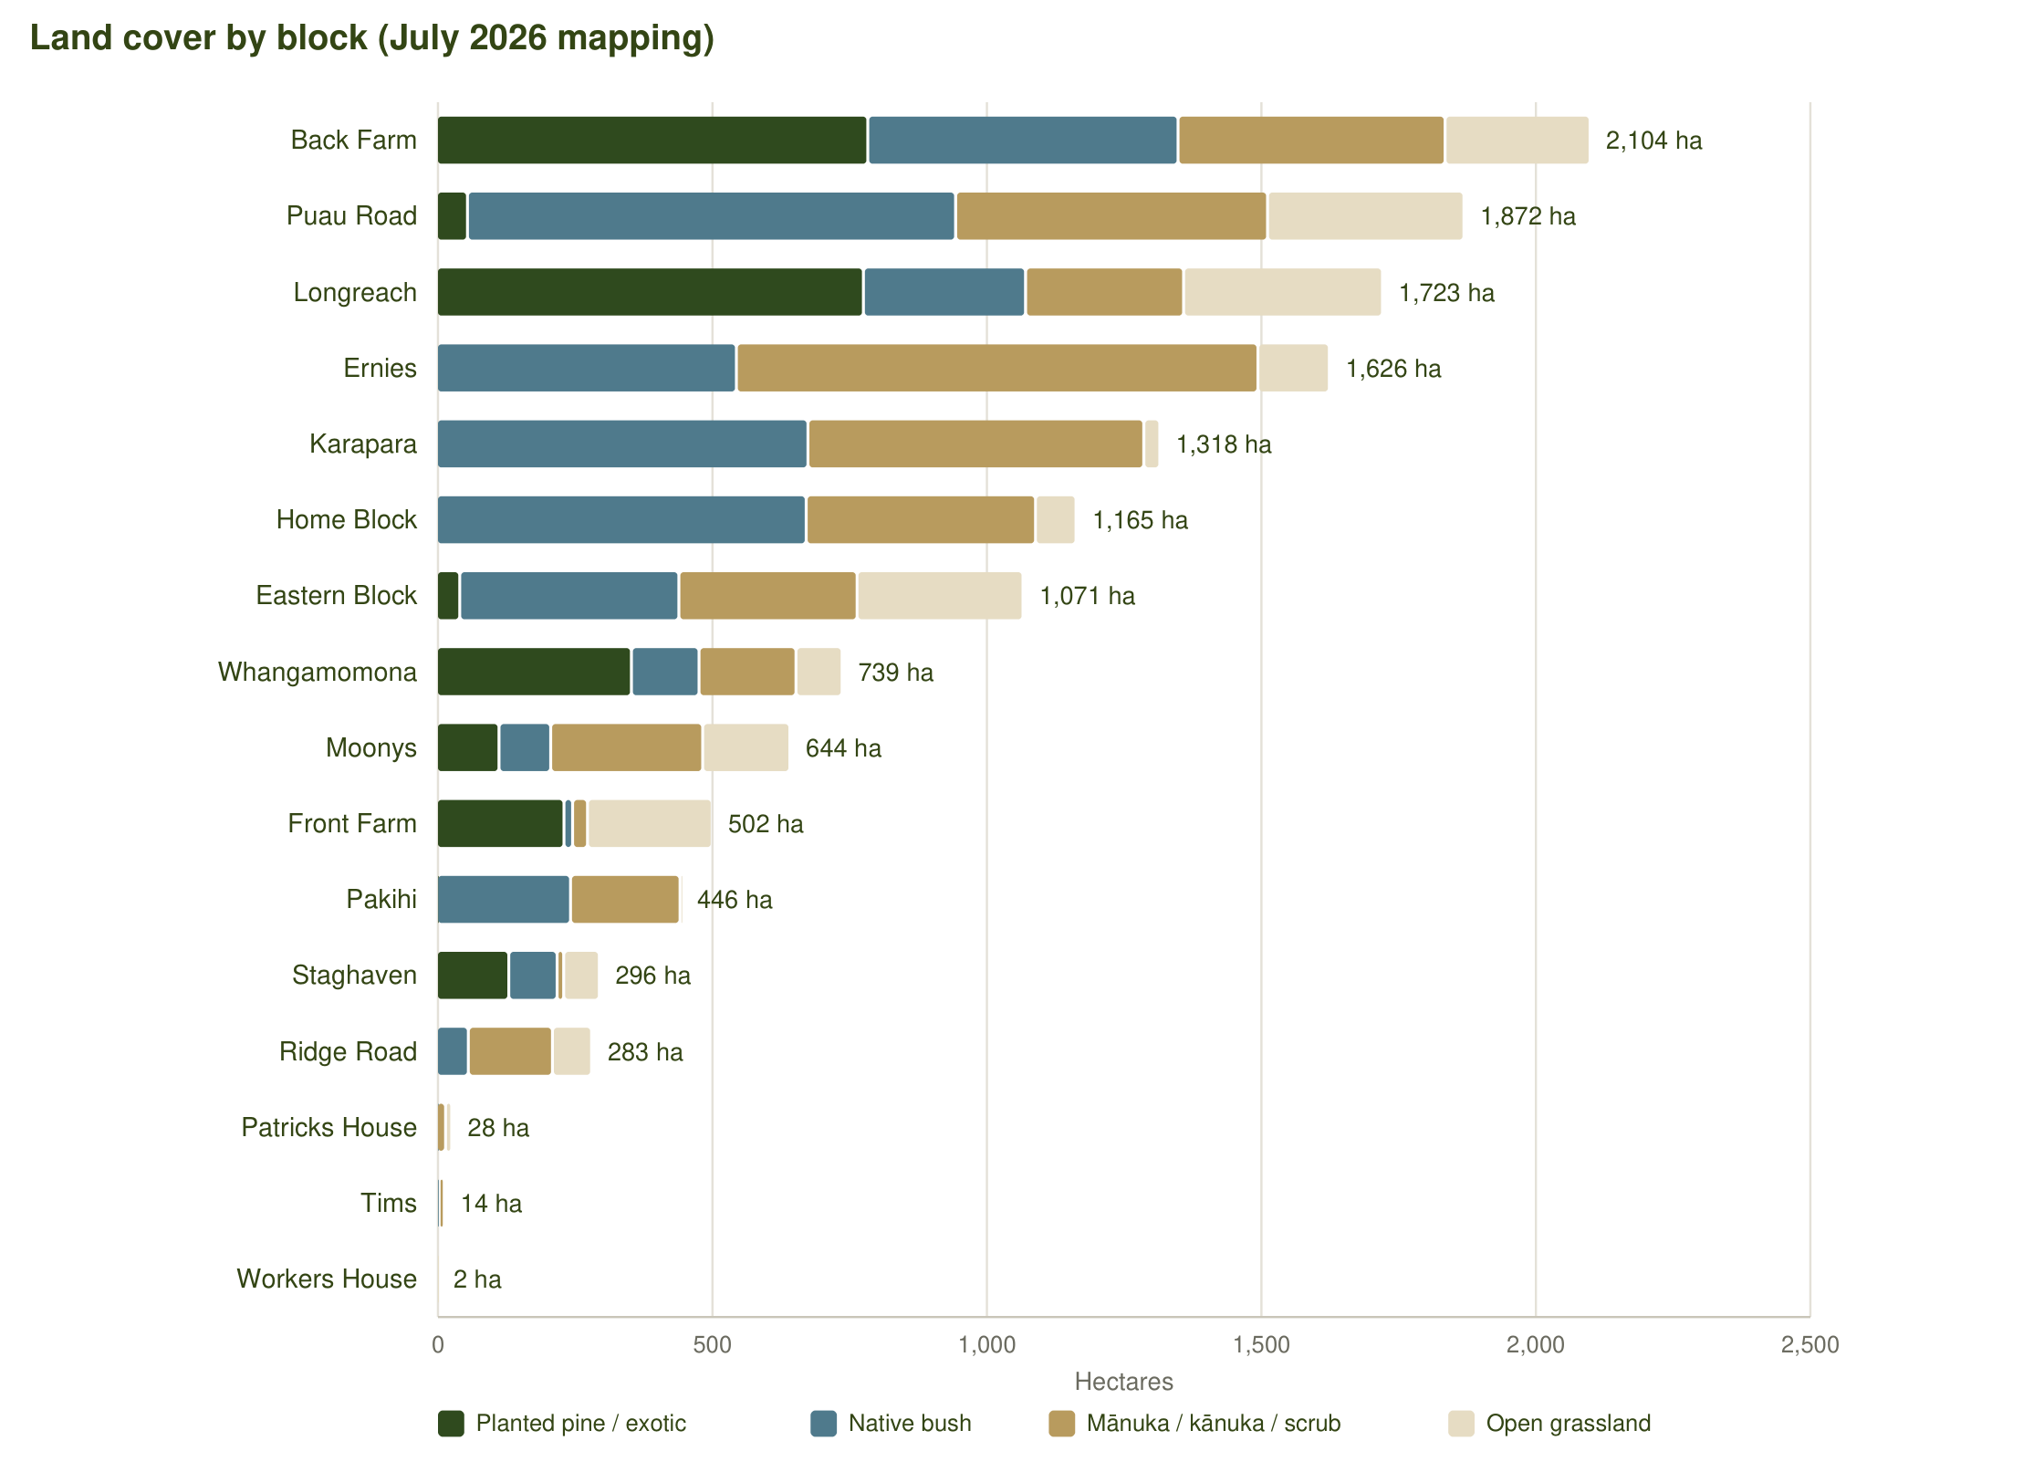
Figure 3 – Land cover by block.
Block | Area (ha) | Pine / exotic | Native bush | Mānuka / kānuka | Open grassland | Water / other
Back Farm | 2,104.4 | 785.6 | 565.2 | 486.5 | 264.0 | 3.0
Longreach | 1,723.1 | 777.7 | 295.3 | 287.8 | 362.3 | –
Eastern Block | 1,071.5 | 42.2 | 399.2 | 324.6 | 302.5 | 2.9
Front Farm | 502.1 | 232.2 | 15.6 | 27.2 | 227.1 | –
Puau Road | 1,871.7 | 56.5 | 889.2 | 568.1 | 357.8 | 0.1
Whangamomona | 738.9 | 355.1 | 123.2 | 176.5 | 84.1 | –
Soldiers Road (forestry right) | 362.2 | 176.1 | 1.4 | 131.3 | 53.3 | 0.1
Staghaven | 295.6 | 131.8 | 87.9 | 12.0 | 65.0 | –
Ernies | 1,626.4 | 0.0 | 546.2 | 950.0 | 130.0 | 0.1
Karapara | 1,317.7 | 0.0 | 676.7 | 611.7 | 28.9 | 0.3
Home Block | 1,165.2 | 0.0 | 673.3 | 417.7 | 73.9 | 0.2
Patricks House | 27.7 | 0.0 | 0.1 | 16.5 | 11.1 | –
Workers House | 1.7 | 0.0 | 0.0 | 0.0 | 1.7 | –
Moonys | 643.6 | 113.7 | 94.2 | 276.9 | 158.8 | –
Ridge Road | 282.6 | 0.0 | 57.9 | 153.3 | 71.3 | 0.1
Tims | 14.3 | 0.0 | 4.9 | 9.4 | 0.0 | –
Pakihi | 445.6 | 0.5 | 243.7 | 199.4 | 2.1 | –
Total (land in the sale) | 13,832.0 | 2,495.2 | 4,672.5 | 4,517.7 | 2,140.6

Internal note – not for the IM: Moonys shows ~114 ha of exotic cover in the mapping but has no ETS registration and no PF Olsen crop – check on the ground before describing it as plantation. Pakihi is mapped as bush/scrub from imagery but as grassland in the LCDB-based spreadsheet; the imagery mapping is used here.

2.3 Location and access
A – Waitōtara Valley / Ngamatapouri (South Taranaki District)
The core of the estate: Back Farm, Front Farm, the Eastern Block, the Home Block, Karapara and Ernies (Makowhai Trust) and Longreach, Patricks House and the Workers House (NFL) lie along Mataimoana, Taumatatahi, Kapara, Makakaho and Waitotara Valley Roads inland from Waverley and Waitōtara. Waverley is 30–70 km by road and Whanganui 55–95 km.
B – Waverley / Nukumaru coast (South Taranaki – Whanganui boundary)
Puau Road, Moonys and Ridge Road sit on the coastal hill country between Waverley and the Waitōtara River mouth, about 30 km from Waverley and 55 km from Whanganui and the Castlecliff port.
C – Eastern Taranaki – Whangamomona / Mangaehu (Stratford District)
Whangamomona (on SH43, the Forgotten World Highway), Tims and Staghaven on Mangaehu Road, and the Soldiers Road forestry right lie in the eastern Taranaki hill country 40–70 km east of Stratford and 80–110 km from New Plymouth and Port Taranaki.
D – Eastern Bay of Plenty – Toatoa (Ōpōtiki District)
Pakihi is 21 km inland from Ōpōtiki on Pakihi Road, 65 km from Whakatāne.
From | Key destinations and road distance (km)
Back Farm (Mataimoana Road) | Waverley 34 · Whanganui 78 · Hāwera 79 · Castlecliff port, Whanganui 82 · Stratford 109 · New Plymouth / Port Taranaki 154
Longreach (Makakaho Road) | Waverley 69 · Whanganui 92 · Castlecliff port, Whanganui 95 · Hāwera 113 · Stratford 143 · New Plymouth / Port Taranaki 188
Puau Road / Moonys / Ridge Road | Waverley 31 · Whanganui 54 · Castlecliff port, Whanganui 57 · Hāwera 75 · Stratford 105 · New Plymouth / Port Taranaki 150
Whangamomona | Stratford 68 · Hāwera 98 · New Plymouth 106 · Port Taranaki 112 · Whanganui 186
Staghaven / Tims (Mangaehu Road) | Stratford 41 · Hāwera 71 · New Plymouth 79 · Port Taranaki 84 · Whanganui 159
Pakihi (Toatoa) | Ōpōtiki 21 · Whakatāne 65 · Gisborne 158

Road distances are approximate (OpenStreetMap routing from the block centroid).
Legal access: no legal access issues are known. Most blocks have road frontage; physical access to some planted stands is through neighbouring properties (Front Farm stands 1.01 and 5.01 via the Dobson farm, the Eastern Block via the Larson property or the Makowhai track network, and Puau Road via Wood Country Limited) and those arrangements need to be re-secured. [TBC – legal access details and easements from Stand (Ross Larcombe).] The grazing lease confers rights for persons under the Receivers' control to cross the leased land.

2.4 Planted forest and the 2026 programme
Pinus radiata was established on eight blocks between 2022 and 2024, mostly in 2023 and 2024, at an original target stocking of 1,100 stems/ha. PF Olsen ground-truthed every planted block in April 2026 after an aerial tree-detection survey had under-reported stocking, and assessed each stand as adequately stocked (above 850 stems/ha), for blanking (scattered survival, about 500 stems/ha infill) or for replanting (failed areas, to 850 stems/ha). Pest pressure from deer, goats and pigs and stock incursions were the main causes of loss.
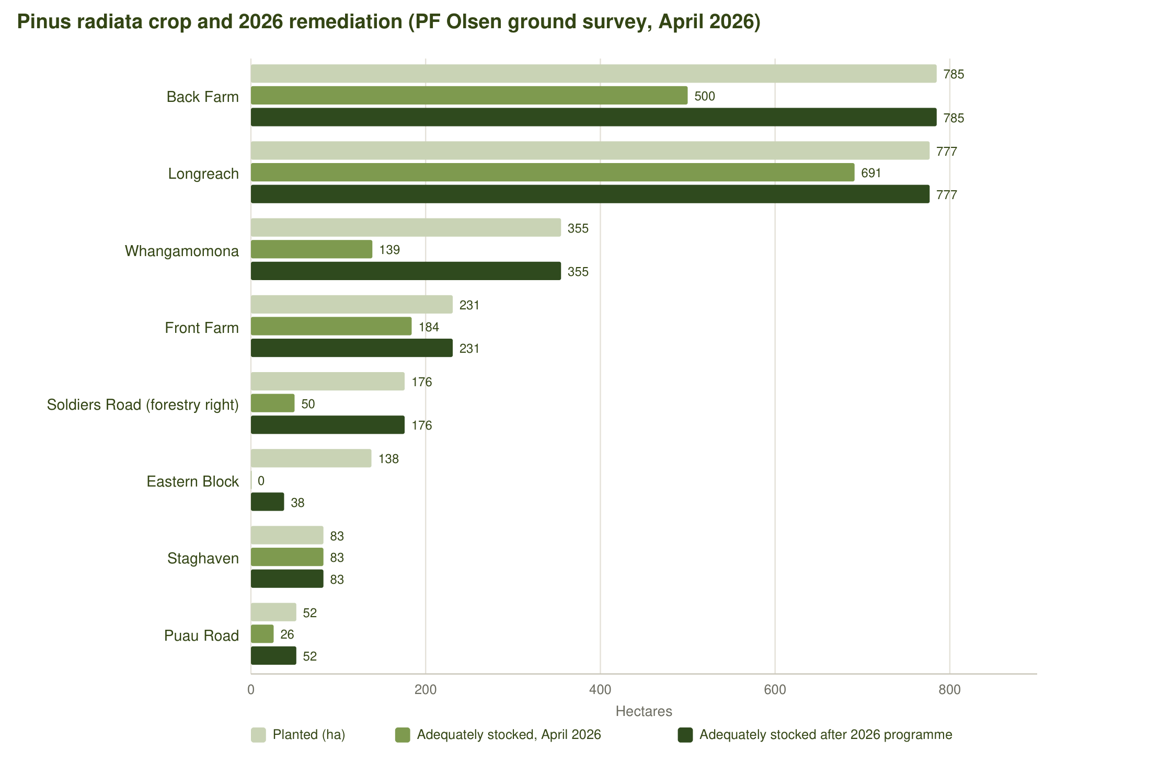
Figure 4 – Planted area, adequately stocked area at April 2026 and after the 2026 programme (PF Olsen).
Block | Planted (ha) | Planting year(s) | Adequate Apr 2026 (ha) | 2026 replant (ha) | 2026 blanking (ha) | Adequate after 2026 (ha) | Further plantable (ha)
Back Farm | 785 | 2022–23 | 500 | 50 | 235 | 785 | 3.5
Longreach | 777 | 2024 | 691 | 27 | 59 | 777 | –
Eastern Block | 138 | 2023–24 | 0 | 18 | 20 | 38 | 70.0
Front Farm | 231 | 2023 | 184 | 12 | 35 | 231 | 140.0
Puau Road | 52 | 2024 | 26 | 17 | 8 | 52 | –
Whangamomona | 355 | 2024 | 139 | 194 | 22 | 355 | 5.5
Soldiers Road (FR) | 176 | 2023 | 50 | 88 | 38 | 176 | –
Staghaven | 83 | 2024 (+2011) | 83 | – | – | 83 | –
Total | 2,597 |  | 1,673 | 406 | 417 | 2,497 | 219

Planting years are from the ETS land status reports (CAA planting year) [TBC – stand records]. 'Adequate' means a current stocking above 850 stems/ha. PF Olsen's programme also covered Stag Haven (no work required). The 2026 programme is reported complete ahead of schedule [TBC – completion certificates and survival plots].
Planting timeline (for the IM table):
Season | Area planted (ha) | Species | Status
2022 | [TBC – c. 330 ha at Back Farm (ETS CAA year)] | Pinus radiata | Established; weakest survival, blanked 2026
2023 | [TBC – c. 900 ha at Back Farm, Front Farm, Eastern Block, Soldiers Road] | Pinus radiata | Established
2024 | [TBC – c. 1,300 ha at Longreach, Whangamomona, Puau Road, Eastern Block, Staghaven] | Pinus radiata | Established
2026 | 406 ha replant + 417 ha blanking | Pinus radiata | Completing end September 2026 [TBC]

Older stands: about 105 ha of 1995–2011 radiata at Longreach (84 ha of it in a permanent-forest CAA), 66 ha of 1994 radiata at Back Farm (permanent-forest CAA 69) and about 22 ha of 2011 radiata at Staghaven are registered in the ETS under stock-change accounting. Their harvest or retention is a purchaser decision subject to the ETS obligations attached to each accounting area.
Forest health and protection: Dothistroma needle blight affects about 150 ha at Whangamomona; comprehensive ongoing pest control is required to hold the restored stocking, and several blocks need stock excluded from planted stands.

2.5 Emissions Trading Scheme and carbon
Two ETS participants hold the registered forest land: Nirvana Farm Limited (participant NZ-10251, MPI holding P-054526), as landowner on its own titles and as forestry-right holder over the Makowhai Trust and Land & Bee's titles, and Makowhai Station (NZ-1181, P-054188) as landowner. The young radiata is registered under averaging accounting; the older stands and regenerating indigenous areas are under stock-change accounting, including two permanent-forest accounting areas (to 2060) at Longreach and across Back Farm, the Eastern Block and the Home Block.
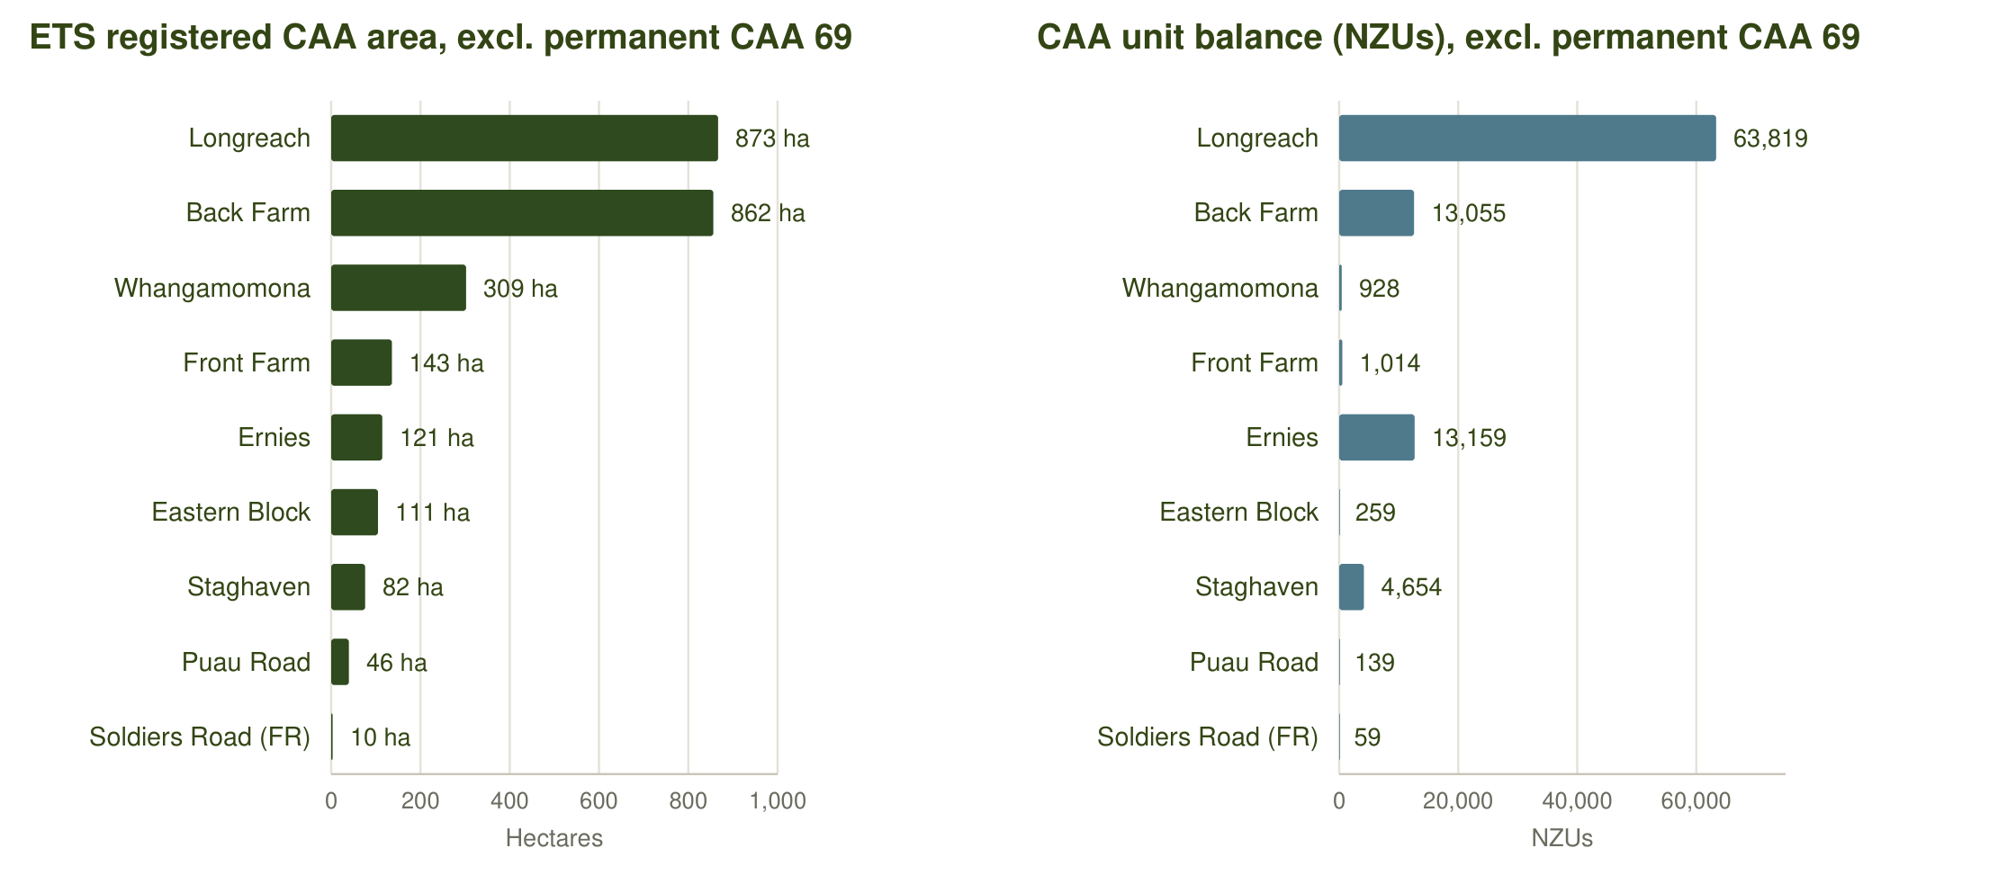
Figure 5 – Registered CAA area and CAA unit balance by block (MPI land status reports, NFL 28 Sep 2026 and Makowhai Station Aug 2025). CAA 69 (183 ha, 52,466 units) is shown separately in the table.
Participant / block | CAA area (ha) | Unit balance (NZUs) | Accounting and planting year
Back Farm – Nirvana Farm Limited (forestry-right holder) | 625.2 | 7,932 | 30 CAAs – P. radiata 2022 (188 ha) and 2023 (437 ha), averaging
Back Farm – Nirvana Farm Limited (forestry-right holder) | 93.2 | 752 | CAA 47 spans Back Farm and Front Farm titles (451953 & TNH1/1356) – P. radiata 2023
Back Farm – Makowhai Station (landowner) | 144.1 | 4,371 | 11 CAAs – P. radiata 2022, averaging
Back Farm – Makowhai Station (landowner) | 111.9 | (in CAA 69) | Part of permanent-forest CAA 69 (post-1989, stock change to 2060): 65.6 ha 1994 P. radiata and 46 ha indigenous on TNA3/681; CAA 69 unit balance 52,466 across Back Farm, Eastern Block and Home Block
Longreach – Nirvana Farm Limited (landowner) | 723.7 | 2,262 | 21 CAAs – P. radiata 2024 plantings, averaging
Longreach – Nirvana Farm Limited (landowner) | 84.2 | 49,574 | CAA 24 – permanent forest (PP89, to 28 May 2060): 1995 and 1997 P. radiata, stock change
Longreach – Nirvana Farm Limited (landowner) | 65.3 | 11,983 | 16 CAAs – 1995–2011 P. radiata (23 ha) and 1997–2007 indigenous (42 ha), stock change, registered 2015–2020
Eastern Block – Nirvana Farm Limited (forestry-right holder) | 111.2 | 259 | 15 CAAs – P. radiata 2023 (25 ha) and 2024 (86 ha), averaging
Front Farm – Nirvana Farm Limited (forestry-right holder) | 108.6 | 752 | 2 CAAs – P. radiata 2023, averaging (plus CAA 47 shared with Back Farm, 93 ha)
Front Farm – Makowhai Station (landowner) | 34.0 | 262 | 3 CAAs – P. radiata 2023, averaging
Puau Road – Nirvana Farm Limited (landowner) | 46.1 | 139 | 5 CAAs – P. radiata 2024, averaging (titles WN115/77 and WN24A/444)
Whangamomona – Nirvana Farm Limited (landowner) | 308.6 | 928 | 17 CAAs – P. radiata 2024, averaging
Soldiers Road (FR) – Nirvana Farm Limited (forestry-right holder) | 9.6 | 59 | 4 CAAs – P. radiata 2023, averaging. The forestry right describes a carbon accounting area of 160 ha; registration of the balance to be confirmed
Staghaven – Nirvana Farm Limited (landowner) | 60.9 | 4,654 | 7 CAAs – P. radiata 2024, averaging (unit balance includes the 2011 stands)
Staghaven – Nirvana Farm Limited (landowner) | 21.6 | (in CAA 69) | 5 CAAs – P. radiata 2011, stock change, registered April 2022 (units included above)
Ernies – Makowhai Station (landowner) | 120.9 | 13,159 | 2 CAAs – post-1989 regenerating indigenous forest (1991 and 1998), stock change, registered 2014
Makowhai Station – CAA 69 permanent forest (Back Farm, Eastern Block, Home Block) | 183.2 | 52,466 | Stock change, permanent forestry to 3 Feb 2060: 65.6 ha 1994 P. radiata and 117.6 ha indigenous
Total | 2,740.2 | 149,552 | NFL 79,294 NZUs · Makowhai Station 70,258 NZUs

CAA unit balances are the units allocated to each carbon accounting area as recorded by MPI; they are not the balance of units held in the participants' holding accounts. [TBC – NZU holding account balances and reconciliation from JTL / NZGT.]
- Carbon account control: the NFL carbon account is controlled by NZGT as trustee, which will control the transfer of units at settlement. Some Makowhai Trust holdings sit in a separate holding account; all NZUs are intended to be transferred to NFL ahead of settlement. NZUs are to be transferred with the property.
- Forward sale: approximately 1.6 million NZUs to year 14 of the young crop were forward-sold to the financier at about $33 per unit (CBRE, October 2024). The Receivers advise that this contract will be extinguished on sale [TBC – wording to be agreed with the Receivers and Vitol]; a short-term forward offtake with a purchaser is a possible structure.
- Eligible land: about 3,190 ha of grassland and scrub on the titled land is indicatively post-1989 (MfE LUCAS baseline) and therefore potentially eligible for registration, subject to MPI determination and the current registration ballot for new exotic forest.
- Section 194A notices for both participants, the land status reports and the CAA geospatial data (27 September 2026) are in the data room. A carbon specialist (JTL – Jason Loveridge) is supplying the ETS information pack.

2.6 Tenure, titles and security
The land is held in 29 Nirvana Farm Limited titles (6,044.8 ha) and 27 Makowhai Trust titles (7,787.2 ha). All are freehold (fee simple) except the two Puau Road titles, which are Crown renewable leases. Nirvana Farm Limited also holds two registered forestry rights that form part of the offering: Forestry Right 12717687.18 over the planted areas of the Makowhai Trust titles (Back Farm, Front Farm and the Eastern Block) and Forestry Right 12717687.19 over the Land & Bee's Limited title at Soldiers Road (RT 153235, 362 ha).
Property / interest | Interest | Included | Notes
Nirvana Farm Limited land (10 blocks incl. Staghaven) | Freehold and two Crown leases | Yes | Vitol mortgage 12717687.17 and land covenant 12717687.16 to be discharged at settlement; PHC Treasury caveat
Makowhai Trust land (6 blocks) | Freehold – receivers appointed over the titles | Yes | Vitol mortgage 12717687.20 to be discharged at settlement; PHC Treasury caveat
Forestry Right 12717687.18 (Makowhai Trust land) | Registered forestry right held by NFL | Yes | Mortgaged to Vitol (12717687.21); copy in the data room [TBC]
Forestry Right 12717687.19 (Soldiers Road, 153235) | Registered forestry right held by NFL | Yes – FR only | Land owned by Land & Bee's Limited is not included; mortgaged to Vitol (12717687.22)
Magons, Buchanans, Kaipikari, Arnold Road, Carroll Street, Whangamomona Road (TNC3/222), Staghaven TNH4/170 | – | No | Not part of the sale
Honey assets and hives | – | No | Owned by the former owner, who will need hive agreements with a purchaser to keep hives on the land

Crown leases (Puau Road)
Titles | 948076 (720.34 ha, Section 1B Block I Nukumaru SD) and 948077 (884.24 ha, Section 1 Block I Nukumaru SD) – Puau Road
Type | Renewable leases under section 82 of the Land Act 1948 (instruments RL 11709159.1 and .2)
Term | 33 years commencing 1 July 2020
Rent | [TBC – copy of lease in the data room]
Note | Reassignment is expected to be straightforward (receivers' advice); 948077 is also within the Pukekahu Farms grazing lease. No pine has been planted on the leased titles.

2.7 Leases and occupation
Farming lease – Pukekahu Farms Limited
Tenant | Pukekahu Farms Limited (guarantors Paul William Kinder and Virginia Kinder-Matthews, Whanganui)
Landlord | Nirvana Farm Limited (55% of rent) and the trustees of the Makowhai Trust (45%)
Term | Five years from 1 January 2025, expiring 31 December 2029
Leased land | Record of Title 948077 (884.24 ha, Puau Road – Crown lease), 451953 (338.57 ha, Front Farm) and TNE3/649 (1,037.11 ha, Eastern Block) – that part shaded on the lease plans, about 2,200 ha
Rent | $105,000 plus GST per annum ($57,750 to NFL, $47,250 to the Makowhai Trust)
Prepayment | Rent for years 1 and 2 was paid in advance; rent for years 3–5 was prepaid at a discounted $250,000 plus GST. No rent is receivable by a purchaser for the balance of the term.
Permitted use | Grazing of sheep and cattle only; no pigs. Tenant may not cut scrub or trees, light fires or apply chemicals near scrub.
Rights reserved | Landlord retains exclusive beekeeping and honey rights, timber, access for forestry and ETS (Climate Change Response Act) purposes; the lease is subject to the registered forestry rights and confers no rights over existing forestry.
Early termination | Landlord may terminate on five months' written notice, on refunding prepaid rent at $83,333.33 plus GST per annum pro rata plus $8,333.33 per month to 31 December 2029.
Dwellings | The tenant is to maintain the two dwellings on the leased land.

Internal note – not for the IM: The prepaid rent is the key disclosure: a purchaser inherits a tenant to December 2029 with no rent receivable, but can terminate on five months' notice by refunding the prepaid balance (about $83,333 pa plus $8,333 per month to 31 Dec 2029). The Receivers also advise the Eastern Block lease was not formally consented to by the financier and could be cleared. Consider whether to market with the lease in place.
Dwellings and occupation
Dwellings are on Patricks House, the Workers House, Front Farm and the Eastern Block (the two dwellings on the leased land) [TBC – full list of dwellings, condition and who occupies each; Stand to verify]. The former owner's residence is believed not to be on the estate. The lessee occupies Front Farm.

2.8 Land characteristics
The estate is typical eastern Taranaki and Waitōtara hill country: mudstone and sandstone ridges with steep faces, easier flats and terraces along the valley floors, and extensive regenerating mānuka/kānuka on the harder faces. Slope from the LINZ 8 m DEM puts most of the open grassland on medium-hill to very steep contour, with the easiest country on Front Farm, Puau Road, Longreach and the Eastern Block.
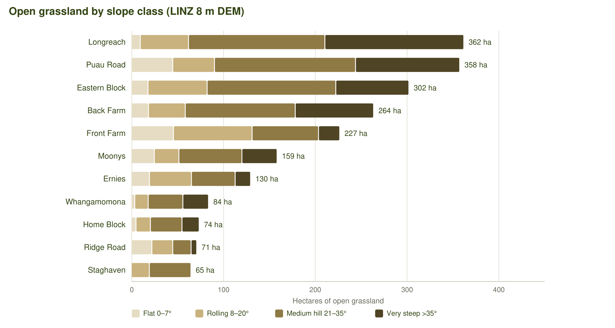
Figure 6 – Open grassland by slope class on blocks with 50 ha or more of open ground.
Climate | Value
Annual sunshine hours | [TBC – NIWA 1981–2010 grid at Ngamatapouri / Whangamomona]
Median annual temperature | [TBC]
Annual rainfall | [TBC – c. 1,400–2,000 mm across the estate; NIWA grid]
Land Use Capability | [TBC – LUC 6 and 7 dominate; LRIS NZLRI classes to be tabulated per block]
Aspect | [TBC – aspect histogram from the DEM for the IM chart]

Internal note – not for the IM: The IM template's climate tiles, LUC and aspect chart currently carry placeholder data. Rainfall and sunshine can be pulled from the MfE/NIWA grids with the same script used for Dargaville; LUC from LRIS is not licensed for commercial use, so use the NZLRI classes via the LINZ/MWLR open layer or leave as a qualitative statement.

2.9 Improvements
Improvements are secondary to the land and forest. Known structures include dwellings at Patricks House, the Workers House and on the leased land (Front Farm and the Eastern Block), woolsheds and yards at Back Farm, Front Farm and Whangamomona, and farm tracks throughout. [TBC – schedule of buildings by block, age, condition and services; CBRE's October 2024 report carried improvement values for each block but no descriptions.] No production figures exist for the farming or honey operations.

2.10 Sale process
The estate is offered for sale by expressions of interest closing at [TBC time] on [TBC date], with international coverage. The process can be tailored to individual purchasers' needs – offers may be made for the whole estate or for individual blocks or groups of blocks – and early offers are unlikely to be accepted. Prices are plus GST (if any). The sale is a receivership sale by the Receivers as agents of the vendors in exercise of their powers as receivers, on an "as is, where is" basis without warranties. Inspections are strictly by appointment with the Receivers' prior approval.
Contact | Role | Phone | Email
Warwick Searle | National Director – Forestry | +64 21 362 778 | warwick@forestrysales.co.nz
James Burke | Forestry Sales | +64 21 824 145 | james@forestrysales.co.nz
George Cashmore | Forestry Sales | +64 21 0264 1362 | george@forestrysales.co.nz

Data room: [TBC – link]. Includes the PF Olsen ground survey (April 2026), ETS land status reports and section 194A notices, CAA geospatial data, titles and instrument searches, the forestry rights, the Pukekahu Farms lease and the Crown leases.

3 Block summaries
Blocks are presented by location and size, Pinus radiata blocks first. Each summary gives the facts for the IM block page, a short narrative, and the items still to be confirmed for that block.
- Pinus radiata blocks: Back Farm, Longreach, Eastern Block, Front Farm (Waitōtara Valley / Ngamatapouri); Puau Road (Nukumaru); Whangamomona, Soldiers Road forestry right, Staghaven (eastern Taranaki).
- Native, mānuka and dwelling blocks: Ernies, Karapara, Home Block, Patricks House, Workers House (Waitōtara Valley); Moonys, Ridge Road (Nukumaru); Tims (Mangaehu Road); Pakihi (Ōpōtiki).

3.1 Back Farm
Waitōtara Valley / Ngamatapouri (South Taranaki District) · Pinus radiata block
Vendor / interest | Trustees of the Makowhai Trust – titles in receivership (A Grenfell and K Johnstone, McGrathNicol)
Records of title | TNA3/681, TNB4/1080, TNB4/1081, TNB4/1082, TNB4/1083, TNE4/125, TNF3/568, TNH1/1356 (Taranaki Land District)
Title area | 2,104.37 ha
Location / address | Mataimoana Road, Waverley (187 Mataimoana Road)
Territorial authority | South Taranaki District
Regional council | Taranaki Regional Council
Land cover (July 2026 mapping) | Pine / exotic 785.6 ha · Native bush 565.2 ha · Mānuka / kānuka 486.5 ha · Open grassland 264.0 ha
Open grassland by slope | flat 18.7 · rolling 40.1 · medium hill 119.9 · very steep 85.4 ha
Pinus radiata crop (PF Olsen, April 2026) | 785 ha planted · 500 ha adequately stocked at April 2026 · 50 ha replant + 235 ha blanking in 2026 · 785 ha adequately stocked after 2026 · 3.5 ha further plantable
ETS carbon accounting areas | Nirvana Farm Limited (forestry-right holder): 625.2 ha, 7,932 NZUs – 30 CAAs – P. radiata 2022 (188 ha) and 2023 (437 ha), averaging; Nirvana Farm Limited (forestry-right holder): 93.2 ha, 752 NZUs – CAA 47 spans Back Farm and Front Farm titles (451953 & TNH1/1356) – P. radiata 2023; Makowhai Station (landowner): 144.1 ha, 4,371 NZUs – 11 CAAs – P. radiata 2022, averaging; Makowhai Station (landowner): 111.9 ha – Part of permanent-forest CAA 69 (post-1989, stock change to 2060): 65.6 ha 1994 P. radiata and 46 ha indigenous on TNA3/681; CAA 69 unit balance 52,466 across Back Farm, Eastern Block and Home Block
Indicatively ETS-eligible land | about 281.0 ha (post-1989 grassland and scrub, MPI to determine)
Leases / occupation | None known [TBC]
Access | Road frontage to Mataimoana Road. Main track from Mataimoana Road to the woolshed needs minor maintenance; aerial lifting of seedlings and chemical needed for parts of the block.
Improvements | [TBC – schedule of buildings] (CBRE Oct 2024 carried $450,000 of improvements)
Rating valuation / rates | [TBC]

Description
The largest planted block in the estate and the core of the Makowhai Trust land. Roughly 785 ha of Pinus radiata was established across 2022 and 2023 on the easier faces of a 2,104 ha hill-country holding, with the balance in native bush and regenerating mānuka/kānuka and about 264 ha of open grassland. PF Olsen's April 2026 ground survey found the 2023 plantings growing well and the 2022 areas the weakest, and programmed 50 ha of replanting and 235 ha of blanking for the 2026 season to bring the whole 785 ha back to a stocking above 850 stems/ha. Deer, with some goats and pigs, are present and an aerial shoot before planting was recommended. An older 65 ha stand of 1994 radiata sits within the permanent-forest carbon accounting area on TNA3/681.

Points to note
- Pest control (deer, goats, pigs) is the main survival risk on the 2026 worked areas.
- The 2022 plantings carry the lowest survival; the 2023 plantings are performing well.
- Planted areas are registered by Nirvana Farm Limited under its forestry right over the Makowhai Trust titles, with a further 144 ha registered by Makowhai Station as landowner.

Items to confirm
- [TBC] Completion certificate and survival plots for the 2026 replant/blanking.
- [TBC] Description of the woolshed and any other improvements (CBRE carried $450,000 of improvements).
- [TBC] Whether the 65.6 ha 1994 stand is to be harvested or retained as permanent forest.

3.2 Longreach
Waitōtara Valley / Ngamatapouri (South Taranaki District) · Pinus radiata block
Vendor / interest | Nirvana Farm Limited (In Receivership)
Records of title | WN24B/478, WN24B/479, WNB4/1119, WNF2/815 (Wellington Land District)
Title area | 1,723.14 ha
Location / address | 1136 and 1022 Makakaho Road, Ngamatapouri
Territorial authority | South Taranaki District
Regional council | Taranaki Regional Council
Land cover (July 2026 mapping) | Pine / exotic 777.7 ha · Native bush 295.3 ha · Mānuka / kānuka 287.8 ha · Open grassland 362.3 ha
Open grassland by slope | flat 9.7 · rolling 52.6 · medium hill 148.7 · very steep 151.4 ha
Pinus radiata crop (PF Olsen, April 2026) | 777 ha planted · 691 ha adequately stocked at April 2026 · 27 ha replant + 59 ha blanking in 2026 · 777 ha adequately stocked after 2026
ETS carbon accounting areas | Nirvana Farm Limited (landowner): 723.7 ha, 2,262 NZUs – 21 CAAs – P. radiata 2024 plantings, averaging; Nirvana Farm Limited (landowner): 84.2 ha, 49,574 NZUs – CAA 24 – permanent forest (PP89, to 28 May 2060): 1995 and 1997 P. radiata, stock change; Nirvana Farm Limited (landowner): 65.3 ha, 11,983 NZUs – 16 CAAs – 1995–2011 P. radiata (23 ha) and 1997–2007 indigenous (42 ha), stock change, registered 2015–2020
Indicatively ETS-eligible land | about 505.8 ha (post-1989 grassland and scrub, MPI to determine)
Leases / occupation | None known [TBC]
Access | Road frontage to Makakaho Road. No tracking work required; about 35 ha of the blanking area is isolated by a bluff and needs aerial access.
Improvements | [TBC – schedule of buildings] (CBRE Oct 2024 carried $655,000 of improvements)
Rating valuation / rates | [TBC]

Description
Longreach is the largest Nirvana Farm Limited block and the best-performing young crop in the estate. About 777 ha of Pinus radiata was planted in 2024 across the 1,723 ha property and PF Olsen found high survival throughout, with only 27 ha of replanting and 59 ha of blanking programmed for 2026. Pest control to date has been effective and only maintenance is needed. The block also carries the estate's most valuable carbon position: an 84 ha permanent-forest accounting area of 1995 and 1997 radiata with a unit balance of about 49,600 NZUs, and a further 65 ha of older pine and regenerating indigenous forest registered under stock change. The balance of the property is native bush, mānuka/kānuka and about 362 ha of open hill country, much of it steep.

Points to note
- Stock have been grazing planted stand 1.03 and should be excluded.
- Approximately 506 ha of open and scrub land is indicatively ETS-eligible (post-1989 land), subject to MPI determination.

Items to confirm
- [TBC] Stand records for the 1995–2011 plantings and the intended regime (permanent or harvest).
- [TBC] Improvements on the block (CBRE carried $655,000).
- [TBC] Whether the 35 ha of bluff-isolated blanking is to be completed or excluded.

3.3 Eastern Block
Waitōtara Valley / Ngamatapouri (South Taranaki District) · Pinus radiata block
Vendor / interest | Trustees of the Makowhai Trust – titles in receivership (A Grenfell and K Johnstone, McGrathNicol)
Records of title | TNB4/1024, TNE3/648, TNE3/649 (Taranaki Land District)
Title area | 1,071.47 ha
Location / address | 776–845 Kapara Road, Ngamatapouri (Makowhai 1A, 1B and 2 Blocks)
Territorial authority | South Taranaki District
Regional council | Taranaki Regional Council
Land cover (July 2026 mapping) | Pine / exotic 42.2 ha · Native bush 399.2 ha · Mānuka / kānuka 324.6 ha · Open grassland 302.5 ha
Open grassland by slope | flat 18.2 · rolling 64.4 · medium hill 140.2 · very steep 79.7 ha
Pinus radiata crop (PF Olsen, April 2026) | 138 ha planted · 0 ha adequately stocked at April 2026 · 18 ha replant + 20 ha blanking in 2026 · 38 ha adequately stocked after 2026 · 70.0 ha further plantable
ETS carbon accounting areas | Nirvana Farm Limited (forestry-right holder): 111.2 ha, 259 NZUs – 15 CAAs – P. radiata 2023 (25 ha) and 2024 (86 ha), averaging; Makowhai Station (landowner): 24.2 ha – Part of permanent-forest CAA 69 – 1991 indigenous on TNE3/649
Indicatively ETS-eligible land | about 537.3 ha (post-1989 grassland and scrub, MPI to determine)
Leases / occupation | Title TNE3/649 (1,037 ha) within the Pukekahu Farms grazing lease to 31 December 2029 (rent prepaid)
Access | Previously worked through the neighbouring Larson property; the track network through the Matthews/Wallace title is suitable but has a culvert near the end of its life. Access permission needs to be re-secured.
Improvements | [TBC – schedule of buildings] (CBRE Oct 2024 carried $755,000 of improvements)
Rating valuation / rates | [TBC]

Description
A 1,071 ha hill-country block adjoining Front Farm and the Home Block. About 138 ha was planted in 2023–24, but stand 1.03 has failed to pest damage in heavy scrub and PF Olsen have excluded it from the 2026 programme because of the difficulty of controlling pests and the helicopter-lifting cost. Stand 1.01 is to be replanted (18 ha) and blanked (20 ha), giving about 38 ha of adequately stocked crop after the 2026 season. The property is predominantly native bush and mānuka/kānuka with roughly 300 ha of open grassland, of which about 70 ha has been identified as plantable new ground. Most of the block (title TNE3/649, 1,037 ha) is within the Pukekahu Farms grazing lease to 31 December 2029 and carries one of the leased dwellings.

Points to note
- Stand 1.03 (about 100 ha) is not being remediated; a purchaser may choose to re-establish it with intensive pest control.
- The Eastern Block lease was granted without the financier's formal consent and could be cleared if required (receivers' advice).
- About 537 ha of open and scrub land is indicatively ETS-eligible.

Items to confirm
- [TBC] Status of the failed stand 1.03 in the ETS (CAA area and any liability on removal from the register).
- [TBC] Improvements (CBRE carried $755,000 – dwelling and farm buildings) and the leased dwelling.
- [TBC] Access arrangement over the Larson property.

3.4 Front Farm
Waitōtara Valley / Ngamatapouri (South Taranaki District) · Pinus radiata block
Vendor / interest | Trustees of the Makowhai Trust – titles in receivership (A Grenfell and K Johnstone, McGrathNicol)
Records of title | 451953, TNF3/564, TNF3/565, TNF3/566, TNF3/567 (Taranaki Land District)
Title area | 502.07 ha
Location / address | 779–865 Taumatatahi Road, Ngamatapouri
Territorial authority | South Taranaki District
Regional council | Taranaki Regional Council
Land cover (July 2026 mapping) | Pine / exotic 232.2 ha · Native bush 15.6 ha · Mānuka / kānuka 27.2 ha · Open grassland 227.1 ha
Open grassland by slope | flat 45.9 · rolling 85.7 · medium hill 72.4 · very steep 23.1 ha
Pinus radiata crop (PF Olsen, April 2026) | 231 ha planted · 184 ha adequately stocked at April 2026 · 12 ha replant + 35 ha blanking in 2026 · 231 ha adequately stocked after 2026 · 140.0 ha further plantable
ETS carbon accounting areas | Nirvana Farm Limited (forestry-right holder): 108.6 ha, 752 NZUs – 2 CAAs – P. radiata 2023, averaging (plus CAA 47 shared with Back Farm, 93 ha); Makowhai Station (landowner): 34.0 ha, 262 NZUs – 3 CAAs – P. radiata 2023, averaging
Indicatively ETS-eligible land | about 234.1 ha (post-1989 grassland and scrub, MPI to determine)
Leases / occupation | Title 451953 (338.6 ha) within the Pukekahu Farms grazing lease to 31 December 2029 (rent prepaid); lessee in occupation
Access | Road frontage to Taumatatahi Road. No tracking work required. Stands 1.01 and 5.01 are reached through the neighbouring Dobson farm on the northern boundary – permission to be obtained.
Improvements | [TBC – schedule of buildings] (CBRE Oct 2024 carried $855,000 of improvements)
Rating valuation / rates | [TBC]

Description
The most developed farm in the estate: 502 ha on Taumatatahi Road with the highest proportion of easy contour, about 231 ha of 2023 Pinus radiata and some 227 ha of open pasture, 140 ha of which PF Olsen identified as suitable for new planting. Survival is good overall (184 ha adequately stocked) with stand 1.03 needing 12 ha of replanting and 35 ha of blanking, largely from pest and stock damage – the forest was never release-sprayed during establishment. Stock have been grazing inside the stands and need to be removed. The farm (title 451953, 338.6 ha) is within the Pukekahu Farms grazing lease to 31 December 2029 and is occupied by the lessee; CBRE's improvement value of $855,000 indicates the main farm buildings and a dwelling.

Points to note
- About 140 ha of open ground is plantable (ETS eligibility would depend on the registration ballot).
- Goats have ring-barked trees in the north of stand 1.01; aerial lifting budget of $3,300 is sufficient.

Items to confirm
- [TBC] Dwelling(s), woolshed, yards and other improvements, and who occupies them.
- [TBC] Fencing between the leased pasture and the planted stands.

3.5 Puau Road
Waverley / Nukumaru coast (South Taranaki – Whanganui boundary) · Pinus radiata block
Vendor / interest | Nirvana Farm Limited (In Receivership)
Records of title | 948076, 948077, WN115/77, WN24A/444 (Wellington Land District)
Title area | 1,871.68 ha
Location / address | Puau Road / Waitotara Valley Road, Nukumaru
Territorial authority | South Taranaki District
Regional council | Taranaki Regional Council
Land cover (July 2026 mapping) | Pine / exotic 56.5 ha · Native bush 889.2 ha · Mānuka / kānuka 568.1 ha · Open grassland 357.8 ha
Open grassland by slope | flat 45.1 · rolling 45.5 · medium hill 153.7 · very steep 113.5 ha
Pinus radiata crop (PF Olsen, April 2026) | 52 ha planted · 26 ha adequately stocked at April 2026 · 17 ha replant + 8 ha blanking in 2026 · 52 ha adequately stocked after 2026
ETS carbon accounting areas | Nirvana Farm Limited (landowner): 46.1 ha, 139 NZUs – 5 CAAs – P. radiata 2024, averaging (titles WN115/77 and WN24A/444)
Indicatively ETS-eligible land | about 445.0 ha (post-1989 grassland and scrub, MPI to determine)
Leases / occupation | Crown lease 948077 (884 ha) within the Pukekahu Farms grazing lease to 31 December 2029 (rent prepaid)
Access | Worked through the neighbouring Wood Country Limited property – permission required. A small amount of tracking ($2,500) is needed to reopen the main ridge track.
Improvements | [TBC – schedule of buildings] (CBRE Oct 2024 carried $75,000 of improvements)
Rating valuation / rates | [TBC]

Description
At 1,872 ha Puau Road is the second-largest block but the least developed: about 1,460 ha is native bush and mānuka/kānuka, with 358 ha of open hill country and a 52 ha stand of 2024 radiata on the two freehold titles. Two of the four titles (948076 and 948077, 1,605 ha) are Crown renewable leases under section 82 of the Land Act 1948 for 33 years from 1 July 2020, and 948077 (884 ha) is also within the Pukekahu Farms grazing lease to 31 December 2029. The northern end of stand 1.01 failed to pest and stock damage and is to be replanted (17 ha) with 8 ha of blanking; heavy gorse in the south needs a release spray. About 445 ha of open and scrub land is indicatively ETS-eligible.

Points to note
- Crown lease reassignment is expected to be straightforward (no pine on the leased titles).
- Goats present at altitude; pest control is essential to the 2026 work.

Items to confirm
- [TBC] Crown lease rent, review dates and consent requirements for assignment.
- [TBC] Boundary of the Pukekahu Farms lease on 948077 (aerial plan in the lease).

3.6 Whangamomona
Eastern Taranaki – Whangamomona / Mangaehu (Stratford District) · Pinus radiata block
Vendor / interest | Nirvana Farm Limited (In Receivership)
Records of title | TNK4/628 (Taranaki Land District)
Title area | 738.94 ha
Location / address | 45–105 Whangamomona Road, Whangamōmona
Territorial authority | Stratford District
Regional council | Taranaki Regional Council
Land cover (July 2026 mapping) | Pine / exotic 355.1 ha · Native bush 123.2 ha · Mānuka / kānuka 176.5 ha · Open grassland 84.1 ha
Open grassland by slope | flat 3.7 · rolling 14.7 · medium hill 37.8 · very steep 28.0 ha
Pinus radiata crop (PF Olsen, April 2026) | 355 ha planted · 139 ha adequately stocked at April 2026 · 194 ha replant + 22 ha blanking in 2026 · 355 ha adequately stocked after 2026 · 5.5 ha further plantable
ETS carbon accounting areas | Nirvana Farm Limited (landowner): 308.6 ha, 928 NZUs – 17 CAAs – P. radiata 2024, averaging
Indicatively ETS-eligible land | about 77.9 ha (post-1989 grassland and scrub, MPI to determine)
Leases / occupation | None known [TBC]
Access | Road frontage to Whangamomona Road (SH43 Forgotten World Highway). About $8,500 of maintenance tracking needed to restore access to parts of the block; aerial lifting into stand 2.
Improvements | [TBC – schedule of buildings] (CBRE Oct 2024 carried $250,000 of improvements)
Rating valuation / rates | [TBC]

Description
A single 739 ha title in 21 parcels wrapping around the Whangamomona township on the Forgotten World Highway. About 355 ha of radiata was planted in 2024, of which only 139 ha was adequately stocked at April 2026: stands 2.01 and 2.02 failed to heavy pest pressure and are programmed for 194 ha of replanting, with 22 ha of blanking elsewhere. Dothistroma needle blight is affecting about 150 ha of compartments 1.01 and 1.02 and treatment (about $15,000) was recommended. PF Olsen note the replanted stands remain at high risk and that the 5.5 ha of unplanted ground behind the hotel and under the old power lines should be planted in priority. The remainder of the block is native bush and mānuka/kānuka with about 84 ha of open hill.

Points to note
- Repeated stock incursions have damaged trees; fencing and stock exclusion are needed.
- The block includes the 46 and 105 Whangamomona Road addresses.

Items to confirm
- [TBC] Improvements (CBRE carried $250,000 – old woolshed and any dwelling) and occupancy.
- [TBC] Whether the 2026 replanting of stands 2.01/2.02 has been completed.

3.7 Soldiers Road (forestry right)
Eastern Taranaki – Whangamomona / Mangaehu (Stratford District) · Pinus radiata block
Vendor / interest | Forestry Right 12717687.19 held by Nirvana Farm Limited (In Receivership) – land owned by Land & Bee's Limited (not included)
Records of title | 153235 (Land & Bee's Limited – land not included) (Taranaki Land District)
Title area | 362.19 ha (forestry right over the whole title; land not included)
Location / address | 202 Tuwharenikau Road (Tawhiwhi Settlement)
Territorial authority | Stratford District [TBC]
Regional council | Taranaki Regional Council
Land cover (July 2026 mapping) | Pine / exotic 176.1 ha · Native bush 1.4 ha · Mānuka / kānuka 131.3 ha · Open grassland 53.3 ha
Open grassland by slope | flat 4.8 · rolling 14.1 · medium hill 21.1 · very steep 13.3 ha
Pinus radiata crop (PF Olsen, April 2026) | 176 ha planted · 50 ha adequately stocked at April 2026 · 88 ha replant + 38 ha blanking in 2026 · 176 ha adequately stocked after 2026
ETS carbon accounting areas | Nirvana Farm Limited (forestry-right holder): 9.6 ha, 59 NZUs – 4 CAAs – P. radiata 2023, averaging. The forestry right describes a carbon accounting area of 160 ha; registration of the balance to be confirmed
Indicatively ETS-eligible land | about 114.3 ha (post-1989 grassland and scrub, MPI to determine)
Leases / occupation | None known [TBC]
Access | One internal track through the centre of the block; much of the planted area is reachable only by air for pest control. Aerial lifting budget $8,800 plus $3,300 for chemical.
Improvements | [TBC – schedule of buildings]
Rating valuation / rates | [TBC]

Description
Offered as a registered forestry right only. Forestry Right 12717687.19 was granted by Land & Bee's Limited to Nirvana Farm Limited over the whole of title 153235 (362 ha) and covers about 176 ha of radiata planted in 2023. PF Olsen found a large part of the crop had failed to pest damage – only 50 ha was adequately stocked – and programmed 88 ha of replanting and 38 ha of blanking for 2026, noting that the scattered fingers of planting among scrub will remain difficult to protect without regular aerial shooting. The land itself is retained by Land & Bee's Limited.

Points to note
- Only the forestry right is for sale; the freehold land is not included.
- The CBRE report records the 176 ha as ETS-registered with carbon pre-sold to year 14.

Items to confirm
- [TBC] Copy of the forestry right (term, rent, harvest and carbon provisions, access rights).
- [TBC] Current ETS registration of the full planted area and the unit balance.
- [TBC] Status of the 2026 replanting.

3.8 Staghaven
Eastern Taranaki – Whangamomona / Mangaehu (Stratford District) · Pinus radiata block
Vendor / interest | Nirvana Farm Limited (In Receivership)
Records of title | TNH4/186, TN118/45, TNH4/183 (Taranaki Land District)
Title area | 295.55 ha
Location / address | 694 Mangaehu Road, Puniwhakau
Territorial authority | Stratford District
Regional council | Taranaki Regional Council
Land cover (July 2026 mapping) | Pine / exotic 131.8 ha · Native bush 87.9 ha · Mānuka / kānuka 12.0 ha · Open grassland 65.0 ha
Open grassland by slope | flat 0.0 · rolling 19.6 · medium hill 45.4 · very steep 0.0 ha
Pinus radiata crop (PF Olsen, April 2026) | 83 ha planted · 83 ha adequately stocked at April 2026 · 0 ha replant + 0 ha blanking in 2026 · 83 ha adequately stocked after 2026
ETS carbon accounting areas | Nirvana Farm Limited (landowner): 60.9 ha, 4,654 NZUs – 7 CAAs – P. radiata 2024, averaging (unit balance includes the 2011 stands); Nirvana Farm Limited (landowner): 21.6 ha – 5 CAAs – P. radiata 2011, stock change, registered April 2022 (units included above)
Indicatively ETS-eligible land | about 26.2 ha (post-1989 grassland and scrub, MPI to determine)
Leases / occupation | None known [TBC]
Access | Road frontage to Mangaehu Road.
Improvements | [TBC – schedule of buildings] (CBRE Oct 2024 carried $50,000 of improvements)
Rating valuation / rates | [TBC]

Description
Three titles totalling 296 ha on Mangaehu Road east of Stratford. About 83 ha of radiata was planted in 2024 on top of some 49 ha of older exotic forest including 2011 stands registered in the ETS; PF Olsen found near-100% survival and no remediation is required. The balance is native bush and about 65 ha of rolling to medium-hill pasture. The fourth Staghaven title (TNH4/170, 156 ha), which carries the homestead, has been sold separately and is not included.

Points to note
- The best-stocked young crop in the estate – no 2026 work required.
- Financier security remains over these titles and will be released at settlement.

Items to confirm
- [TBC] Stand records for the older exotic areas (about 49 ha) and their regime.
- [TBC] Access and any easements following the separate sale of TNH4/170.

3.9 Ernies
Waitōtara Valley / Ngamatapouri (South Taranaki District) · Native / mānuka block
Vendor / interest | Trustees of the Makowhai Trust – titles in receivership (A Grenfell and K Johnstone, McGrathNicol)
Records of title | 421910, TN175/43, TN175/44, TNH4/190, TNJ2/204, TNJ2/714 (Taranaki Land District)
Title area | 1,626.37 ha
Location / address | Sections 2–20 Moewatea Road, Ngamatapouri
Territorial authority | South Taranaki District
Regional council | Taranaki Regional Council
Land cover (July 2026 mapping) | Native bush 546.2 ha · Mānuka / kānuka 950.0 ha · Open grassland 130.0 ha
Open grassland by slope | flat 19.8 · rolling 45.7 · medium hill 47.6 · very steep 16.9 ha
Pinus radiata crop (PF Olsen, April 2026) | None
ETS carbon accounting areas | Makowhai Station (landowner): 120.9 ha, 13,159 NZUs – 2 CAAs – post-1989 regenerating indigenous forest (1991 and 1998), stock change, registered 2014
Indicatively ETS-eligible land | about 687.7 ha (post-1989 grassland and scrub, MPI to determine)
Leases / occupation | None known [TBC]
Access | Moewatea Road frontage [TBC].
Improvements | [TBC – schedule of buildings] (CBRE Oct 2024 carried $500,000 of improvements)
Rating valuation / rates | [TBC]

Description
A 1,626 ha mānuka/kānuka and native bush block west of the Home Block, historically run for honey production. About 950 ha is regenerating mānuka/kānuka and 546 ha mature native forest, with 130 ha of open ground. Two carbon accounting areas of regenerating indigenous forest (121 ha) are registered by Makowhai Station with a unit balance of about 13,200 NZUs, and roughly 690 ha of the scrub and grassland is indicatively post-1989 and therefore potentially ETS-eligible – the largest eligible area of any block. CBRE carried $500,000 of improvements.

Points to note
- No Pinus radiata on the block.
- The largest indicatively ETS-eligible area in the estate (about 688 ha, MPI to determine).

Items to confirm
- [TBC] Improvements and any dwelling/occupancy.
- [TBC] Legal and physical access.

3.10 Karapara
Waitōtara Valley / Ngamatapouri (South Taranaki District) · Native / mānuka block
Vendor / interest | Trustees of the Makowhai Trust – titles in receivership (A Grenfell and K Johnstone, McGrathNicol)
Records of title | TN227/30, TN227/31, TN227/32 (Taranaki Land District)
Title area | 1,317.71 ha
Location / address | 1, 3 and 4A Waitotara Valley Road
Territorial authority | South Taranaki District
Regional council | Taranaki Regional Council
Land cover (July 2026 mapping) | Native bush 676.7 ha · Mānuka / kānuka 611.7 ha · Open grassland 28.9 ha
Open grassland by slope | flat 1.6 · rolling 6.0 · medium hill 14.0 · very steep 7.4 ha
Pinus radiata crop (PF Olsen, April 2026) | None
ETS carbon accounting areas | No carbon accounting areas registered
Indicatively ETS-eligible land | about 3.1 ha (post-1989 grassland and scrub, MPI to determine)
Leases / occupation | None known [TBC]
Access | Waitotara Valley Road frontage [TBC].
Improvements | [TBC – schedule of buildings] (CBRE Oct 2024 carried $400,000 of improvements)
Rating valuation / rates | [TBC]

Description
A 1,318 ha block that is almost entirely native bush (677 ha) and regenerating mānuka/kānuka (612 ha), with under 30 ha of open ground. It is a honey and conservation block rather than a development property, and almost none of it is indicatively ETS-eligible as post-1989 land. CBRE carried $400,000 of improvements.

Points to note
- No Pinus radiata on the block.

Items to confirm
- [TBC] Improvements and occupancy.
- [TBC] Legal access.

3.11 Home Block
Waitōtara Valley / Ngamatapouri (South Taranaki District) · Native / mānuka block
Vendor / interest | Trustees of the Makowhai Trust – titles in receivership (A Grenfell and K Johnstone, McGrathNicol)
Records of title | TN119/223, TNE3/650 (Taranaki Land District)
Title area | 1,165.17 ha
Location / address | 776–845 Kapara Road, Ngamatapouri
Territorial authority | South Taranaki District
Regional council | Taranaki Regional Council
Land cover (July 2026 mapping) | Native bush 673.3 ha · Mānuka / kānuka 417.7 ha · Open grassland 73.9 ha
Open grassland by slope | flat 5.1 · rolling 15.7 · medium hill 34.4 · very steep 18.7 ha
Pinus radiata crop (PF Olsen, April 2026) | None
ETS carbon accounting areas | Makowhai Station (landowner): 18.5 ha – Part of permanent-forest CAA 69 – 1996 indigenous on TN119/223
Indicatively ETS-eligible land | about 259.8 ha (post-1989 grassland and scrub, MPI to determine)
Leases / occupation | None known [TBC]
Access | Kapara Road frontage [TBC].
Improvements | [TBC – schedule of buildings] (CBRE Oct 2024 carried $275,000 of improvements)
Rating valuation / rates | [TBC]

Description
Two titles of 1,165 ha between Front Farm and the Eastern Block: 673 ha of native bush, 418 ha of mānuka/kānuka and about 74 ha of open ground. About 260 ha of the scrub and grassland is indicatively post-1989 and potentially ETS-eligible. CBRE carried $275,000 of improvements. The private residence occupied by the former owner is understood not to be on the land being sold.

Points to note
- No Pinus radiata on the block.

Items to confirm
- [TBC] Improvements and occupancy; confirm the former owner's residence is outside the sale titles.

3.12 Patricks House
Waitōtara Valley / Ngamatapouri (South Taranaki District) · Dwelling block
Vendor / interest | Nirvana Farm Limited (In Receivership)
Records of title | 690021, WN53B/169, WN53B/170 (Wellington Land District)
Title area | 27.66 ha
Location / address | 2606 Waitotara Valley Road, Waitōtara
Territorial authority | South Taranaki District
Regional council | Taranaki Regional Council
Land cover (July 2026 mapping) | Native bush 0.1 ha · Mānuka / kānuka 16.5 ha · Open grassland 11.1 ha
Open grassland by slope | flat 6.5 · rolling 2.2 · medium hill 1.9 · very steep 0.3 ha
Pinus radiata crop (PF Olsen, April 2026) | None
ETS carbon accounting areas | No carbon accounting areas registered
Indicatively ETS-eligible land | about 27.6 ha (post-1989 grassland and scrub, MPI to determine)
Leases / occupation | None known [TBC]
Access | Road frontage to Waitotara Valley Road.
Improvements | [TBC – schedule of buildings] (CBRE Oct 2024 carried $300,000 of improvements)
Rating valuation / rates | [TBC]

Description
A 27.7 ha dwelling block on the Waitotara Valley Road with about 11 ha of easy to rolling pasture and 16 ha of scrub. CBRE carried $300,000 of improvements, being the house and outbuildings.

Items to confirm
- [TBC] Dwelling description, condition and occupancy (a tenant, 'Rex', is believed to occupy one of the estate dwellings).

3.13 Workers House
Waitōtara Valley / Ngamatapouri (South Taranaki District) · Dwelling block
Vendor / interest | Nirvana Farm Limited (In Receivership)
Records of title | TNE3/610, TNE3/611 (Taranaki Land District)
Title area | 1.71 ha
Location / address | 228 Taumatatahi Road, Ngamatapouri
Territorial authority | South Taranaki District
Regional council | Taranaki Regional Council
Land cover (July 2026 mapping) | Open grassland 1.7 ha
Open grassland by slope | flat 1.7 · rolling 0.0 · medium hill 0.0 · very steep 0.0 ha
Pinus radiata crop (PF Olsen, April 2026) | None
ETS carbon accounting areas | No carbon accounting areas registered
Indicatively ETS-eligible land | about 1.6 ha (post-1989 grassland and scrub, MPI to determine)
Leases / occupation | None known [TBC]
Access | Road frontage to Taumatatahi Road.
Improvements | [TBC – schedule of buildings] (CBRE Oct 2024 carried $150,000 of improvements)
Rating valuation / rates | [TBC]

Description
Two small sections (1.7 ha) on Taumatatahi Road with a workers' dwelling (CBRE improvements $150,000).

Items to confirm
- [TBC] Dwelling description, condition and occupancy.

3.14 Moonys
Waverley / Nukumaru coast (South Taranaki – Whanganui boundary) · Native / mānuka block
Vendor / interest | Nirvana Farm Limited (In Receivership)
Records of title | WN110/44, WN181/222, WN23A/665, WN476/64 (Wellington Land District)
Title area | 643.62 ha
Location / address | 12–19 Waikare Road and Lakes Road, Nukumaru
Territorial authority | South Taranaki / Whanganui District [TBC]
Regional council | Taranaki / Horizons Regional Council [TBC]
Land cover (July 2026 mapping) | Pine / exotic 113.7 ha · Native bush 94.2 ha · Mānuka / kānuka 276.9 ha · Open grassland 158.8 ha
Open grassland by slope | flat 25.0 · rolling 26.8 · medium hill 68.7 · very steep 38.3 ha
Pinus radiata crop (PF Olsen, April 2026) | None
ETS carbon accounting areas | No carbon accounting areas registered
Indicatively ETS-eligible land | about 35.8 ha (post-1989 grassland and scrub, MPI to determine)
Leases / occupation | None known [TBC]
Access | Waikare Road / Lakes Road frontage [TBC].
Improvements | [TBC – schedule of buildings] (CBRE Oct 2024 carried $100,000 of improvements)
Rating valuation / rates | [TBC]

Description
A 644 ha block of mixed scrub, native and open hill country near the Waverley coast, adjoining Ridge Road and Puau Road. The appraisal mapping shows about 277 ha of mānuka/kānuka, 94 ha of native bush, 159 ha of open grassland and about 114 ha of exotic forest cover. No radiata has been established under the current programme and there is no ETS registration on the block, so the mapped exotic cover needs to be checked on the ground.

Points to note
- Not in PF Olsen's planting programme; no ETS CAAs.

Items to confirm
- [TBC] Nature and age of the ~114 ha mapped as exotic forest cover (older plantation, wilding pine or scrub).
- [TBC] Improvements (CBRE $100,000) and occupancy.

3.15 Ridge Road
Waverley / Nukumaru coast (South Taranaki – Whanganui boundary) · Native / mānuka block
Vendor / interest | Nirvana Farm Limited (In Receivership)
Records of title | 753569, WN526/225, WN8C/173 (Wellington Land District)
Title area | 282.59 ha
Location / address | 1464 Ridge Road, Nukumaru
Territorial authority | South Taranaki / Whanganui District [TBC]
Regional council | Taranaki / Horizons Regional Council [TBC]
Land cover (July 2026 mapping) | Native bush 57.9 ha · Mānuka / kānuka 153.3 ha · Open grassland 71.3 ha
Open grassland by slope | flat 22.3 · rolling 22.8 · medium hill 20.0 · very steep 6.2 ha
Pinus radiata crop (PF Olsen, April 2026) | None
ETS carbon accounting areas | No carbon accounting areas registered
Indicatively ETS-eligible land | about 65.6 ha (post-1989 grassland and scrub, MPI to determine)
Leases / occupation | None known [TBC]
Access | Road frontage to Ridge Road.
Improvements | [TBC – schedule of buildings] (CBRE Oct 2024 carried $35,000 of improvements)
Rating valuation / rates | [TBC]

Description
A 283 ha block of regenerating scrub (153 ha) and native (58 ha) with about 71 ha of open ground, much of it flat to rolling. About 66 ha is indicatively ETS-eligible.

Points to note
- No Pinus radiata on the block.

Items to confirm
- [TBC] Improvements (CBRE $35,000).

3.16 Tims
Eastern Taranaki – Whangamomona / Mangaehu (Stratford District) · Dwelling block
Vendor / interest | Nirvana Farm Limited (In Receivership)
Records of title | 646771 (Taranaki Land District)
Title area | 14.32 ha
Location / address | 1210 Upper Mangaehu Road
Territorial authority | Stratford District
Regional council | Taranaki Regional Council
Land cover (July 2026 mapping) | Native bush 4.9 ha · Mānuka / kānuka 9.4 ha
Open grassland by slope | –
Pinus radiata crop (PF Olsen, April 2026) | None
ETS carbon accounting areas | No carbon accounting areas registered
Indicatively ETS-eligible land | Negligible
Leases / occupation | None known [TBC]
Access | Road frontage to Upper Mangaehu Road.
Improvements | [TBC – schedule of buildings] (CBRE Oct 2024 carried $5,000 of improvements)
Rating valuation / rates | [TBC]

Description
A 14 ha block of native and scrub on Upper Mangaehu Road, near Staghaven.

3.17 Pakihi
Eastern Bay of Plenty – Toatoa (Ōpōtiki District) · Native / mānuka block
Vendor / interest | Nirvana Farm Limited (In Receivership)
Records of title | GS5C/1448, GS6C/1378, GS6C/1379, GS6C/1380 (Gisborne Land District)
Title area | 445.60 ha
Location / address | Pakihi Road, Toatoa (573 / 1016 Pakihi Road)
Territorial authority | Ōpōtiki District
Regional council | Bay of Plenty Regional Council
Land cover (July 2026 mapping) | Pine / exotic 0.5 ha · Native bush 243.7 ha · Mānuka / kānuka 199.4 ha · Open grassland 2.1 ha
Open grassland by slope | flat 0.5 · rolling 0.9 · medium hill 0.5 · very steep 0.2 ha
Pinus radiata crop (PF Olsen, April 2026) | None
ETS carbon accounting areas | No carbon accounting areas registered
Indicatively ETS-eligible land | about 1.3 ha (post-1989 grassland and scrub, MPI to determine)
Leases / occupation | None known [TBC]
Access | Road frontage to Pakihi Road.
Improvements | [TBC – schedule of buildings] (CBRE Oct 2024 carried $100,000 of improvements)
Rating valuation / rates | [TBC]

Description
The one outlying block: 446 ha of mānuka and native bush on Pakihi Road inland from Ōpōtiki, about 21 km from the town. The appraisal mapping records 244 ha of native bush and 199 ha of mānuka/kānuka; CBRE's land classes (15 ha easy, 362 ha medium hill, 68 ha steep) describe it as a mānuka honey block. It is geographically separate from the Taranaki–Whanganui estate and could suit a separate purchaser.

Points to note
- No Pinus radiata on the block; almost none of the land is indicatively post-1989.

Items to confirm
- [TBC] Land cover – the LCDB-based classification shows the block as open grassland, the 2023/24 imagery as bush and scrub.
- [TBC] Improvements (CBRE $100,000) and occupancy.

Appendix A Schedule of titles
Title and area details from the LINZ register (agency agreement schedules, 14 and 21 September 2026). Areas are hectares.
Block | Vendor | Record of title | Area (ha)
Back Farm | Makowhai Trust | TNA3/681 – Fee simple | 212.8646
Back Farm | Makowhai Trust | TNB4/1080 – Fee simple | 121.4057
Back Farm | Makowhai Trust | TNB4/1081 – Fee simple | 283.2799
Back Farm | Makowhai Trust | TNB4/1082 – Fee simple | 258.1894
Back Farm | Makowhai Trust | TNB4/1083 – Fee simple | 256.9754
Back Farm | Makowhai Trust | TNE4/125 – Fee simple | 142.4493
Back Farm | Makowhai Trust | TNF3/568 – Fee simple | 475.1009
Back Farm | Makowhai Trust | TNH1/1356 – Fee simple | 354.0999
Longreach | NFL | WN24B/478 – Fee simple | 1,605.3905
Longreach | NFL | WN24B/479 – Fee simple | 16.1874
Longreach | NFL | WNB4/1119 – Fee simple | 2.4534
Longreach | NFL | WNF2/815 – Fee simple | 99.1126
Eastern Block | Makowhai Trust | TNB4/1024 – Fee simple | 6.3232
Eastern Block | Makowhai Trust | TNE3/648 – Fee simple | 28.0371
Eastern Block | Makowhai Trust | TNE3/649 – Fee simple | 1,037.1081
Front Farm | Makowhai Trust | 451953 – Fee simple | 338.5727
Front Farm | Makowhai Trust | TNF3/564 – Fee simple | 40.4686
Front Farm | Makowhai Trust | TNF3/565 – Fee simple | 45.3248
Front Farm | Makowhai Trust | TNF3/566 – Fee simple | 47.3482
Front Farm | Makowhai Trust | TNF3/567 – Fee simple | 30.3514
Puau Road | NFL | 948076 – Crown lease (s82 Land Act 1948) | 720.3404
Puau Road | NFL | 948077 – Crown lease (s82 Land Act 1948) | 884.2381
Puau Road | NFL | WN115/77 – Fee simple | 259.4035
Puau Road | NFL | WN24A/444 – Fee simple | 7.7016
Whangamomona | NFL | TNK4/628 – Fee simple | 738.9428
Staghaven | NFL | TNH4/186 – Fee simple | 242.8113
Staghaven | NFL | TN118/45 – Fee simple | 44.7178
Staghaven | NFL | TNH4/183 – Fee simple | 8.0229
Ernies | Makowhai Trust | 421910 – Fee simple | 352.8488
Ernies | Makowhai Trust | TN175/43 – Fee simple | 239.2704
Ernies | Makowhai Trust | TN175/44 – Fee simple | 216.0010
Ernies | Makowhai Trust | TNH4/190 – Fee simple | 138.1466
Ernies | Makowhai Trust | TNJ2/204 – Fee simple | 172.1916
Ernies | Makowhai Trust | TNJ2/714 – Fee simple | 507.9107
Karapara | Makowhai Trust | TN227/30 – Fee simple | 765.3162
Karapara | Makowhai Trust | TN227/31 – Fee simple | 546.3256
Karapara | Makowhai Trust | TN227/32 – Fee simple | 6.0703
Home Block | Makowhai Trust | TN119/223 – Fee simple | 687.6368
Home Block | Makowhai Trust | TNE3/650 – Fee simple | 477.5290
Patricks House | NFL | 690021 – Fee simple | 27.2445
Patricks House | NFL | WN53B/169 – Fee simple | 0.2079
Patricks House | NFL | WN53B/170 – Fee simple | 0.2083
Workers House | NFL | TNE3/610 – Fee simple | 0.6121
Workers House | NFL | TNE3/611 – Fee simple | 1.1002
Moonys | NFL | WN110/44 – Fee simple | 80.9371
Moonys | NFL | WN181/222 – Fee simple | 432.0449
Moonys | NFL | WN23A/665 – Fee simple | 46.4594
Moonys | NFL | WN476/64 – Fee simple | 84.1746
Ridge Road | NFL | 753569 – Fee simple | 89.7128
Ridge Road | NFL | WN526/225 – Fee simple | 6.9201
Ridge Road | NFL | WN8C/173 – Fee simple | 185.9531
Tims | NFL | 646771 – Fee simple | 14.3204
Pakihi | NFL | GS5C/1448 – Fee simple | 57.4906
Pakihi | NFL | GS6C/1378 – Fee simple | 191.6400
Pakihi | NFL | GS6C/1379 – Fee simple | 191.6200
Pakihi | NFL | GS6C/1380 – Fee simple | 4.8461
Total |  | 56 titles | 13,831.9606
Soldiers Road | Forestry Right 12717687.19 (NFL) | 153235 – fee simple, Land & Bee's Limited (land not included) | (362.1936)

Appendix B Items to confirm before release
- Confirmation that the 2026 replanting and blanking programme is complete, with completion certificates, survival plots and the independent third-party review (Cam Eyre).
- Stand records: species, planting year and net stocked area by stand for every block (Stand / Ross Larcombe), replacing the ETS CAA planting years used here.
- NZU holding account balances for NFL and Makowhai Station, reconciliation of units sold or transferred, NZGT trustee documentation, and the agreed wording on the 1.6 million-unit forward sale.
- Copies of Forestry Rights 12717687.18 and 12717687.19: term, rent, carbon and harvest provisions, and the registered CAA areas under each.
- Crown lease rent, review and assignment requirements for 948076 and 948077.
- Schedule of dwellings and farm buildings by block with condition and occupancy (Stand to verify); confirmation that the former owner's residence is outside the sale titles.
- Rating valuations and annual rates for all 56 titles; territorial authority and zoning per title.
- Legal access details and easements; practical access arrangements through the Dobson, Larson and Wood Country properties.
- Climate (NIWA sunshine, temperature, rainfall), LUC and aspect data for the land-characteristics page.
- Moonys: nature of the ~114 ha mapped as exotic cover. Pakihi: land cover on the ground.
- Marketing position on the Pukekahu Farms lease (retain, or terminate before settlement).
- EOI closing date, time and data room link; brand (Searle Forestry vs Searle Agribusiness) for the layout.

Appendix C Sources
- Searle Forestry, Nivarna Farms Appraisal for Vitol, July 2026, and Staghaven appraisal addendum, September 2026 – land-cover and slope mapping by block (internal; values not reproduced).
- PF Olsen, Nirvana Farm Limited Ground Survey, 23 April 2026 – planted areas, survival, 2026 replanting and blanking programme, access and pest notes.
- MPI land status reports – Nirvana Farm Limited (28 September 2026) and Makowhai Station (August 2025); CAA geospatial data 27 September 2026; section 194A notices.
- CBRE, Market Valuation TAR-282069, 14 October 2024 – addresses, land classes, improvement values, carbon forward sale (internal; values not reproduced).
- Agency agreements, Nirvana Farm Limited (In Receivership) and Makowhai Trust land (Receivers), September 2026 – title schedules and scope.
- Vitol – Nirvana Farm prepayment facility security summary; LINZ title and instrument searches (October 2026).
- Deed of Lease of Farmland – Pukekahu Farms Limited (2025); Crown renewable leases 948076 and 948077.
- Stakeholder introduction meeting notes (McGrathNicol, Vitol, Searle Forestry), September 2026.

